INVENTION DISCLOSURE FORM
Braking Mechanism with Automatic Reserve Brake for Cranes and Lifting Apparatus

PROJECT TITLE | Braking Mechanism with Automatic Reserve Brake for Cranes and Lifting Apparatus
INVENTORS | Anne Lever — Chief Mechanical Engineer, Lever & Clutcher Engineering Ltd  Matt Clutcher — Senior Design Engineer, Lever & Clutcher Engineering Ltd
DATE | 12 August 2026
EXTERNAL DATA FILES | FICPI_Drawings_(Preparatory).docx

TITLE
Braking Mechanism with Automatic Reserve Brake for Cranes and Lifting Apparatus

SUMMARY
Our invention relates to a braking mechanism for cranes and similar lifting apparatus. It uses a main brake and a reserve brake, arranged so that the reserve brake comes into operation with a delay relative to the main brake.
In a first embodiment illustrated in FIGS. 1 to 3, the braking mechanism comprises a first main brake 10 and a second reserve brake 20 arranged as band brakes associated with a winding drum mounted on a winding drum shaft 31.
The first main brake 10 has a first fixed end 11 of the brake band secured adjacent to the drum. A first arm 12 extends from the brake mechanism and is mounted on a common shaft 30. The common shaft 30 is controllable by electrical, mechanical, pneumatic, steam or hydraulic means to operate the braking mechanism. A counterweight 40 is connected to the first arm 12 to apply the first main brake 10 when the control means is released.
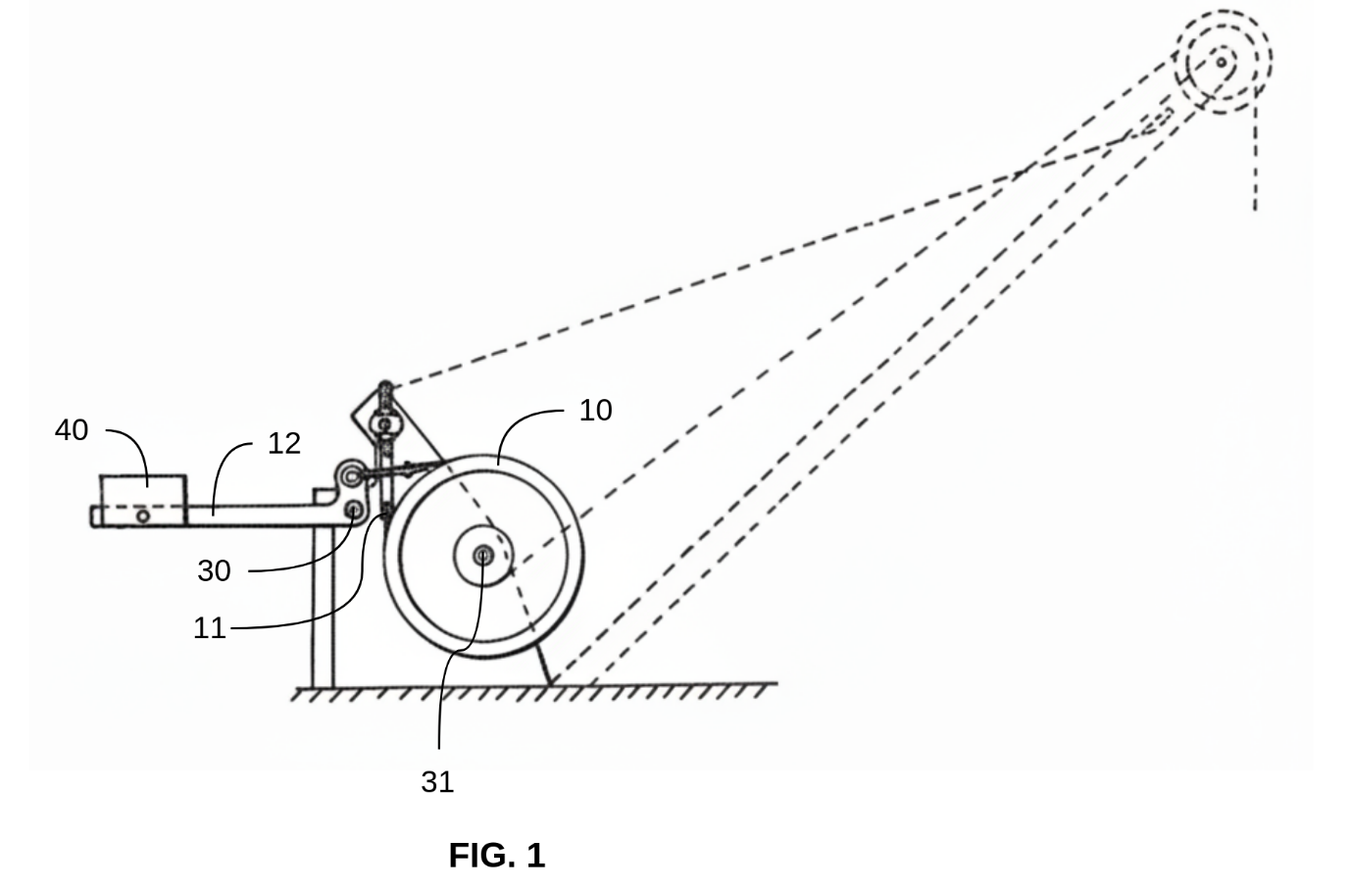
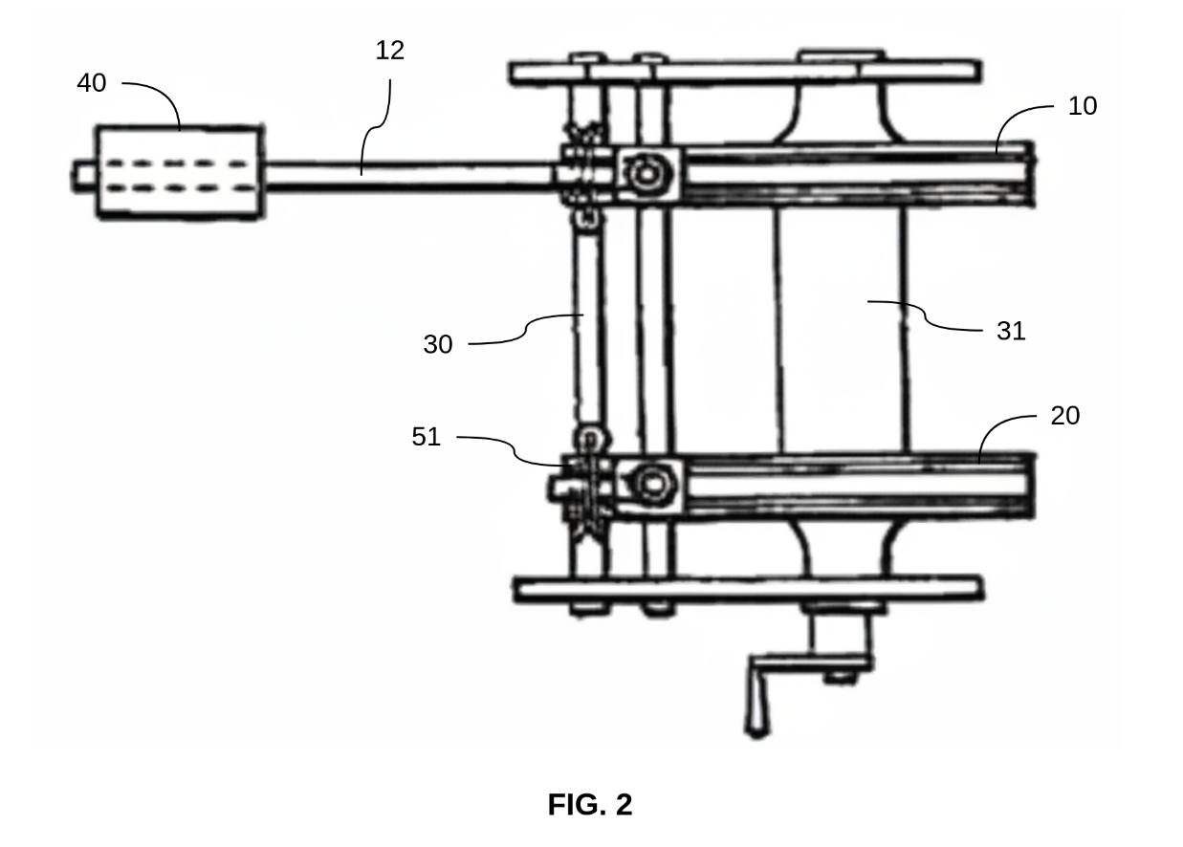
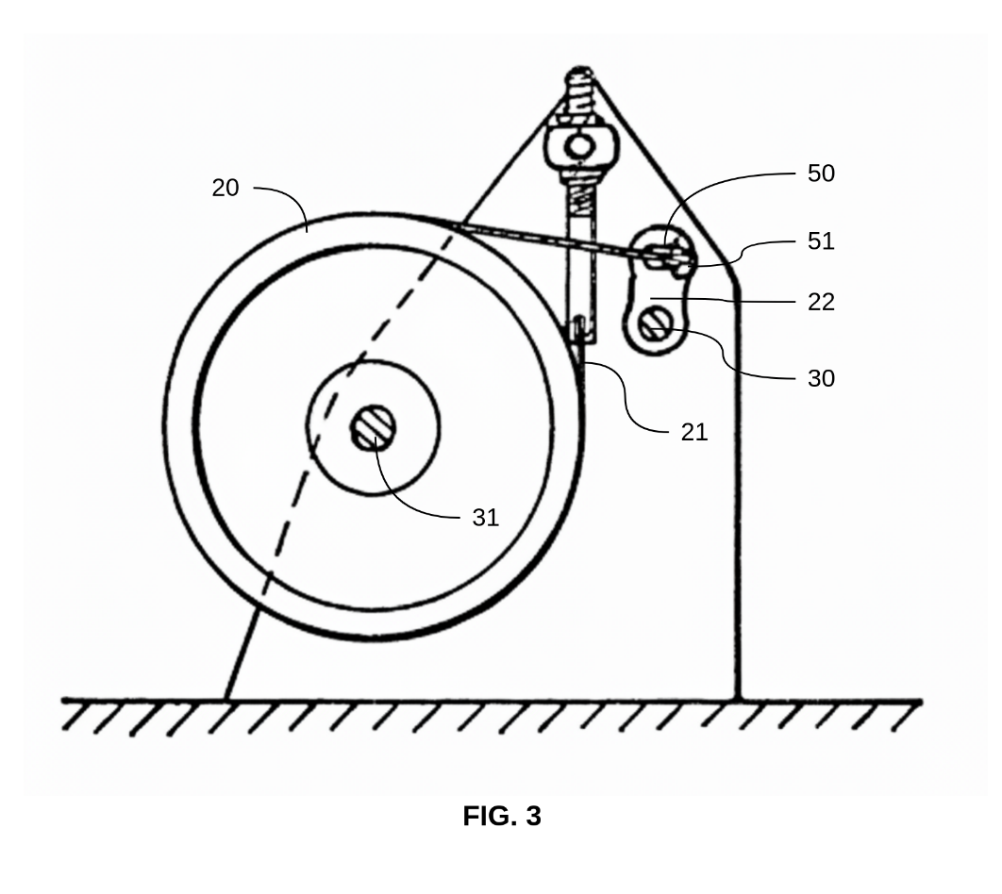
The second reserve brake 20 is arranged next to the first main brake 10, with its brake band wrapping around an adjacent region of the winding drum. A pin 50 and slot 51 connection is provided between the linkage and the second reserve brake 20, forming a lost motion connection that provides a delay action between the two brakes. This means the second reserve brake 20 does not normally operate at the same time as the first main brake 10, but will automatically and rapidly engage if the first main brake 10 fails.
A second arm 22 is mounted on the common shaft 30, and a second fixed end 21 of the brake band is secured at a connection point on the support structure.
In a second embodiment illustrated in FIGS. 4 to 9, the braking mechanism comprises a first main brake 110 and a second reserve brake 120 arranged as brake shoe brakes.
The first main brake 110 is shown as a circular brake drum with a spoked wheel configuration, having a central hub and multiple radial spokes extending outward to an outer rim. A first bell crank 191 is mounted above the brake drum housing and is connected to a first lever 181, which extends downwardly along the side of the brake drum. A solenoid 160, provided as a cylindrical component, controls the brake operation. A counterweight 140 is configured to apply the first main brake 110 when the solenoid 160 is de-energised.
A common shaft 130 passes through the assembly and is controllable to operate the braking mechanism. A first arm 112 and a second arm 122 are mounted on the common shaft 130 and provide the operating connections for the respective brakes.

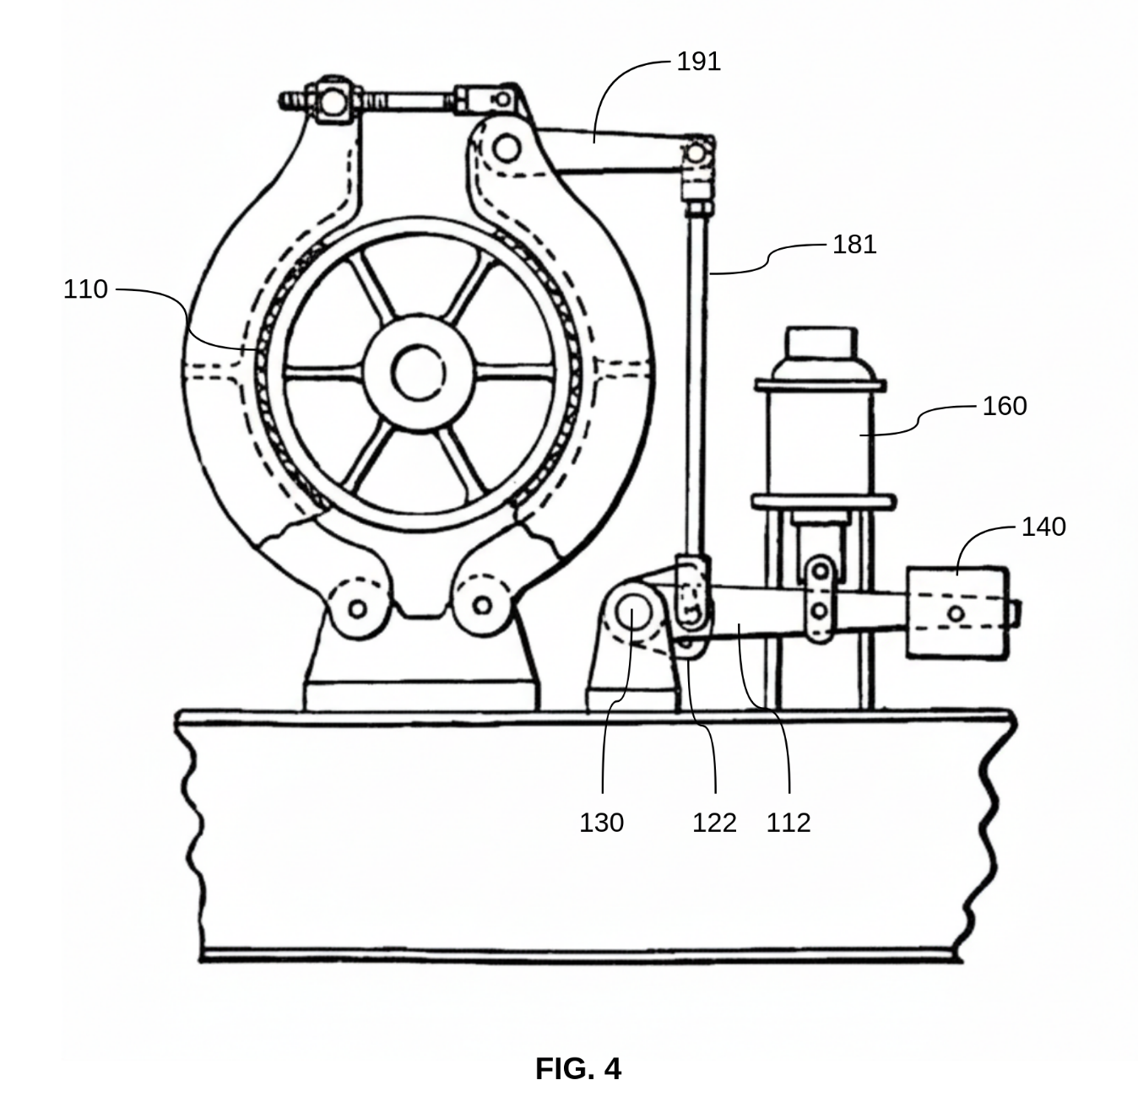
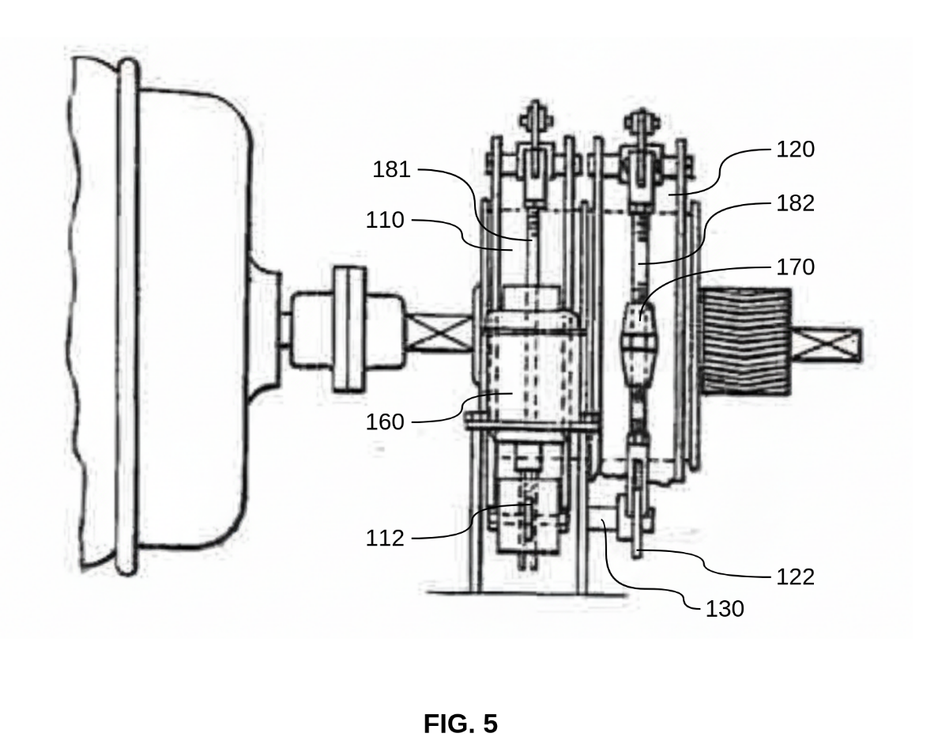
The second reserve brake 120 comprises a brake drum with a spoked wheel configuration, with a brake band wrapping around a portion of the drum circumference. A second bell crank 192 is mounted above the brake drum and is connected to a second lever 182. A turn buckle 170 is provided as an adjustable-length component with threaded engagement at each end, allowing length adjustment in the linkage between the operating arms and the brake components.

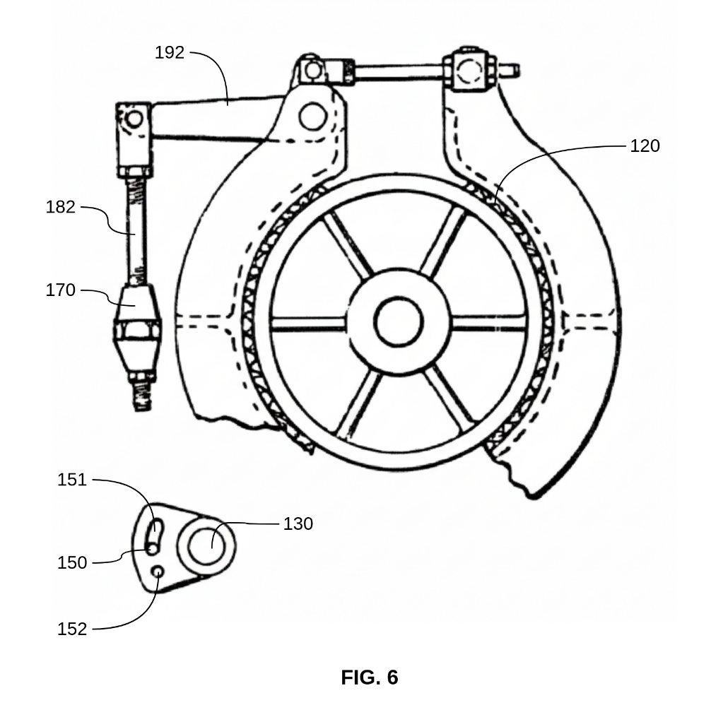
A pin 150 and slot 151 connection is provided between the first arm 112 and the second arm 122, forming a lost motion connection. A hole 152 is also provided adjacent to the slot 151. This allows either a direct pin-and-hole connection or a pin-and-slot connection, depending on whether the brake is configured as the primary operating brake or as a reserve emergency brake. The reserve brake can be converted to function as the main brake by repositioning the pin 150 from the slot 151 to the hole 152, with the turn buckle 170 used to adjust the linkage length for this change.
During normal operation, movement of the output member in the braking direction causes the main brake to engage without engaging the reserve brake. If the main brake fails, the output member moves further in the braking direction, taking up the lost motion in the pin and slot connection and causing the reserve brake to engage automatically and substantially instantaneously.

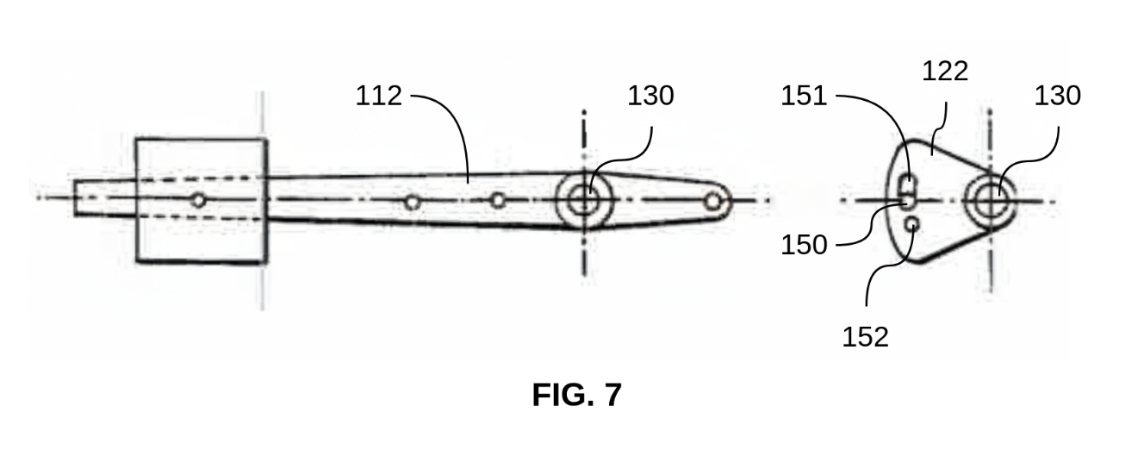
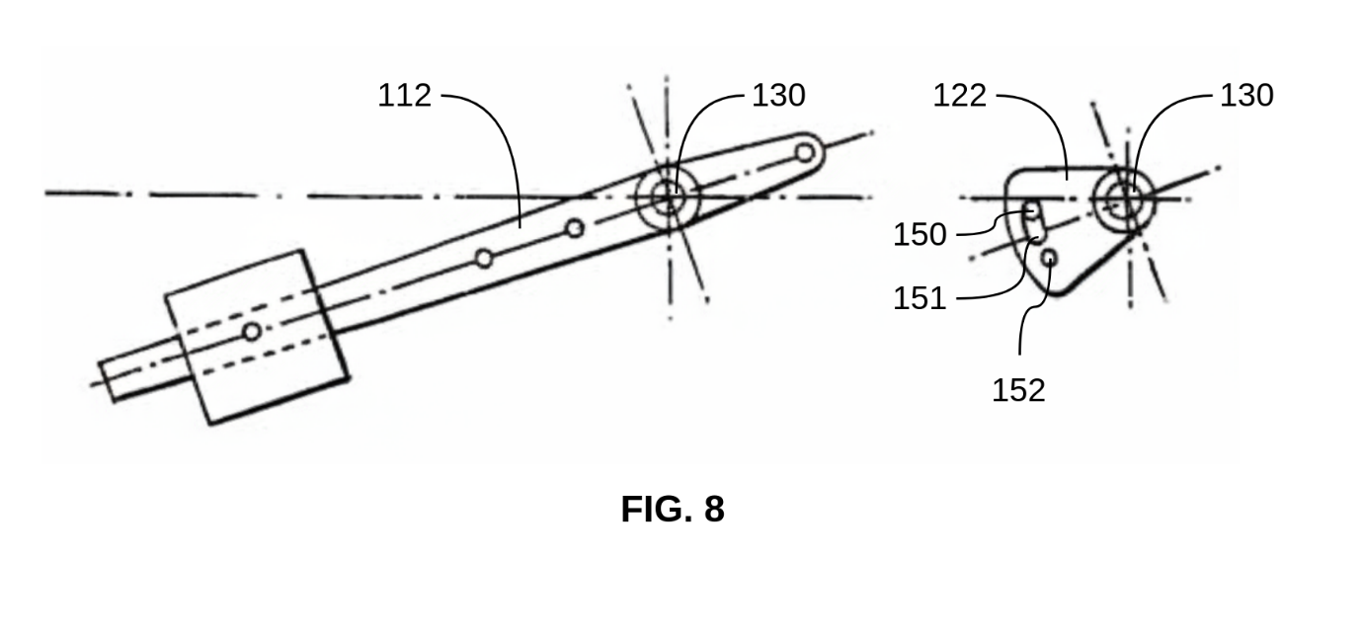
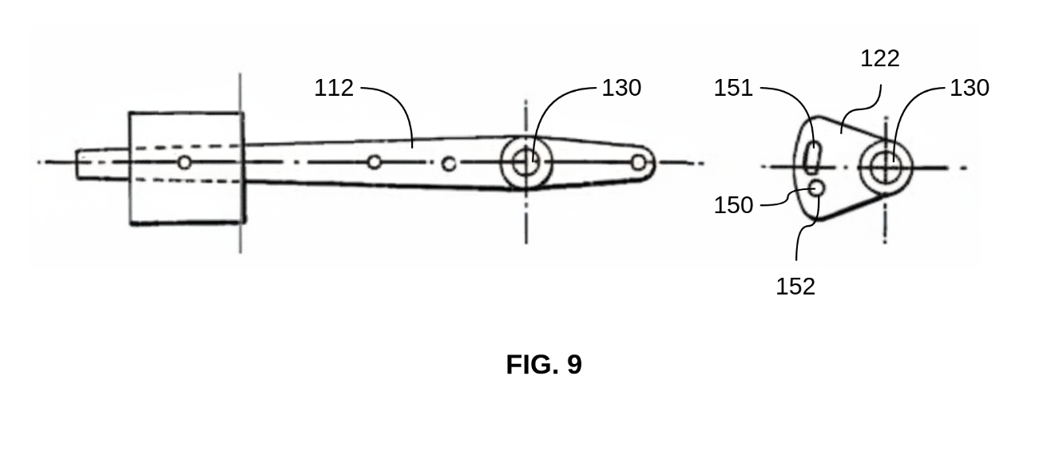

ADVANTAGES
The braking mechanism of the present invention provides several advantages over existing brakes for cranes and lifting apparatus.
The arrangement of a main brake and a reserve brake with a delay action between them means that if the main brake fails, the reserve brake is automatically and substantially instantaneously brought into operation. This addresses the problem with existing band brakes, which tend to break due to whip of the band in use, potentially causing damage when the lifting tackle is loaded at the time of failure.
During normal operation, only the main brake is engaged, so the reserve brake is not subject to unnecessary wear and remains available for emergency use.
The pin and slot connection that provides the delay action is a simple and reliable mechanical arrangement and does not require complex control systems.
The reserve brake may also be converted to function as the main brake when the main brake is removed for repair or is otherwise out of action, so braking capability is maintained during maintenance periods.
The braking mechanism is also versatile. It can be applied to both band brakes and brake shoe brakes, and can be controlled by electrical, mechanical, pneumatic, steam or hydraulic means.

MOTIVATION
The motivation for the present invention came from complaints about existing band brakes used in cranes and similar lifting apparatus. These brakes tend to break due to whip of the band in use. If the lifting tackle is loaded at the time, this can lead to damage when the breakage occurs.
To address this, new constructions were developed to overcome these issues. The result is the present invention, which provides an automatic reserve brake that is brought into operation substantially instantaneously if the main brake fails.

POSSIBLE COMMERCIAL APPLICATIONS
The braking mechanism of the present invention is applicable to cranes and similar lifting apparatus. Potential commercial applications include tower cranes and mobile cranes used in construction, overhead travelling cranes in manufacturing facilities and warehouses, dock cranes and container handling equipment at ports, mine hoists and shaft winding equipment, elevators and lift systems for goods and personnel, winches and hoisting equipment in marine applications, and any lifting apparatus where failure of the braking system could result in damage to equipment or injury to personnel.
The invention addresses a known safety issue in the industry. Existing band brakes tend to break due to whip of the band in use, and if the lifting tackle is loaded at the time of failure, damage can occur. The automatic reserve brake provides a fail-safe mechanism that operates substantially instantaneously if the main brake fails, preventing uncontrolled descent of loaded lifting tackle.
The braking mechanism is also versatile. It can be used with both band brakes and brake shoe brakes, and can be controlled by electrical, mechanical, pneumatic, steam or hydraulic means. This makes it suitable for integration into a wide range of existing crane and lifting apparatus designs.
The reserve brake can also be converted to function as the main brake during maintenance periods. This helps reduce downtime and allows continued operation while the main brake is removed for repair.

